Spring Testing Exercises

Exercise 1: Basic Unit Test for a Service Method
Task: Write a unit test for a service method that adds two numbers.

Service:

@Service
public class CalculatorService { public int add(int a, int b) {
return a + b;
}
}

Test:

Write code for this.

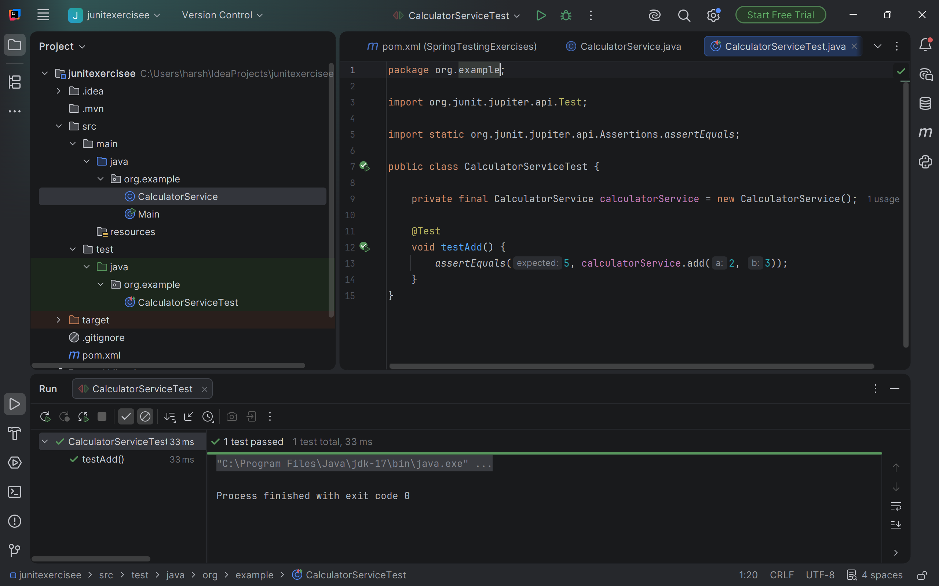

Exercise 2: Mocking a Repository in a Service Test
Task: Test a service that uses a repository to fetch data.

Entity:

@Entity
public class User { @Id
private Long id; private String name;
// getters and setters
}

Repository:

public interface UserRepository extends JpaRepository<User, Long> {
}

Service:

@Service
public class UserServic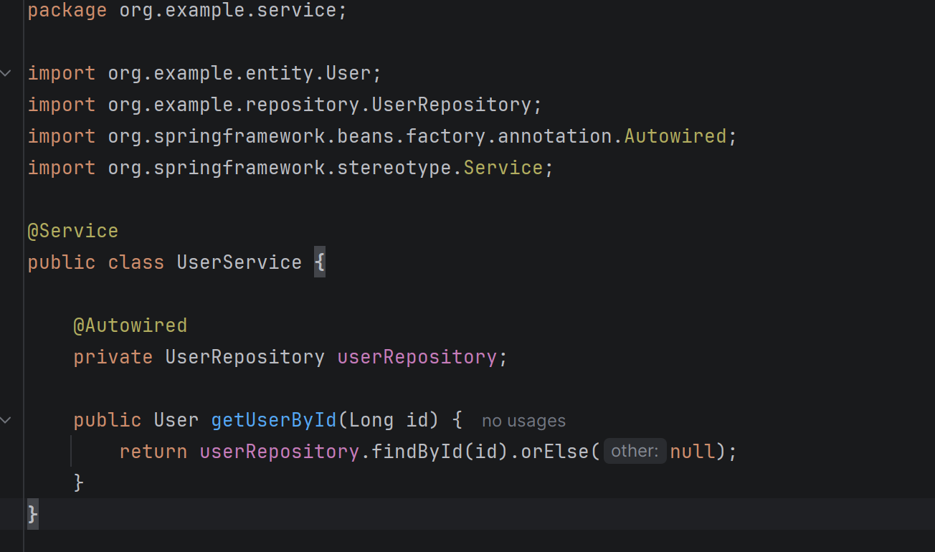e {

@Autowired
private UserRepository userRepository;

public User getUserById(Long id) {
return userRepository.findById(id).orElse(null);
}
}

Test:

Write code for this.

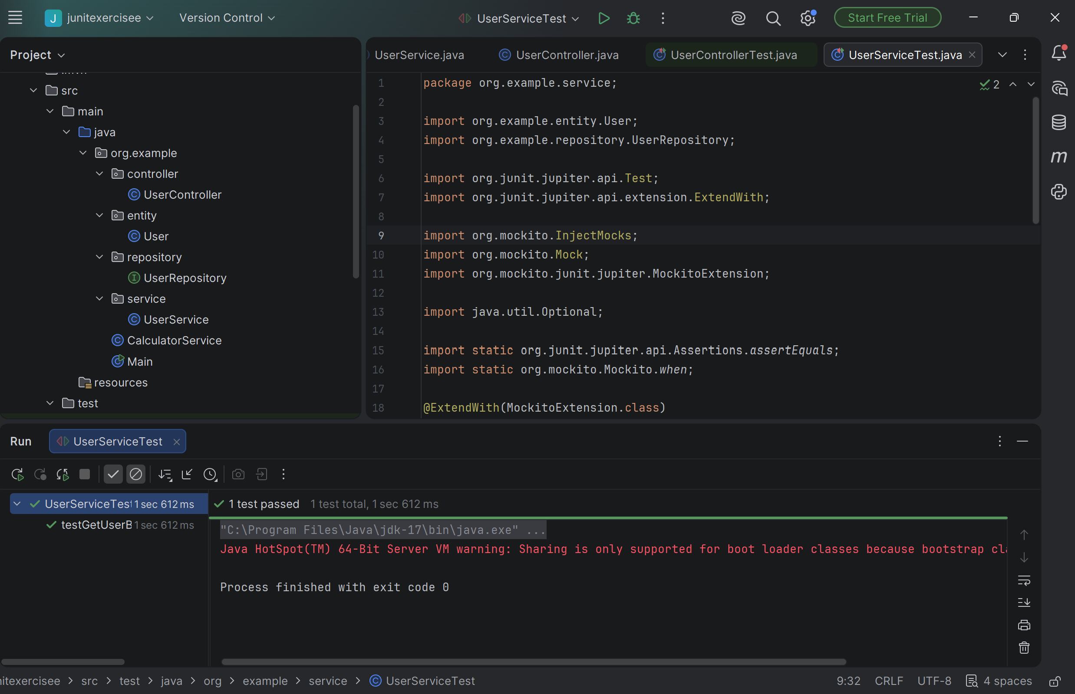

Exercise 3: Testing a REST Controller with MockMvc
Task: Test a controller endpoint that returns a user.

Controller:

@RestController @RequestMapping("/users") public class UserController {

@Autowired
private UserService userService;

@GetMapping("/{id}")
public ResponseEntity<User> getUser(@PathVariable Long id) { return ResponseEntity.ok(userService.getUserById(id));
}
}

Test:

Write code for this.

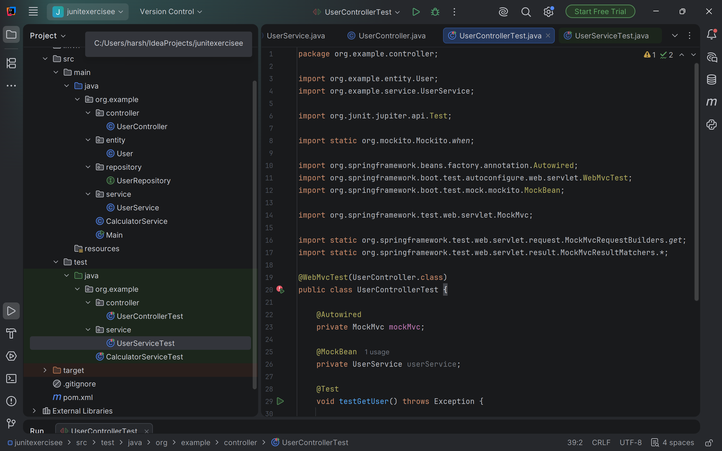

Exercise 4: Integration Test with Spring Boot
Task: Write an integration test that tests the full flow from controller to database.

Test:

Write code for this.
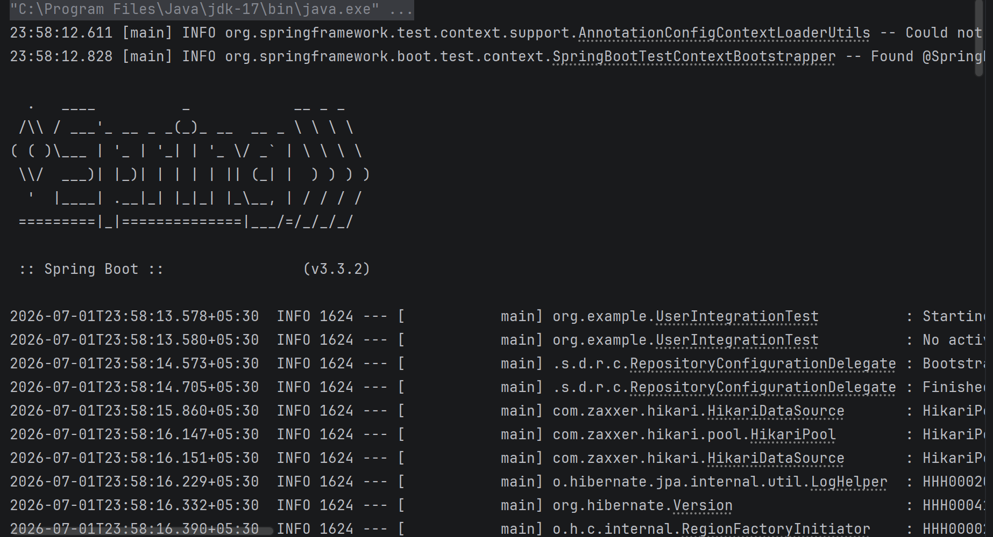

Exercise 5: Test Controller POST Endpoint
Task: Test a POST endpoint that creates a user.

Controller:

@PostMapping
public ResponseEntity<User> createUser(@RequestBody User user) { return ResponseEntity.ok(userService.saveUser(user));
}

Test:

Write code for this.
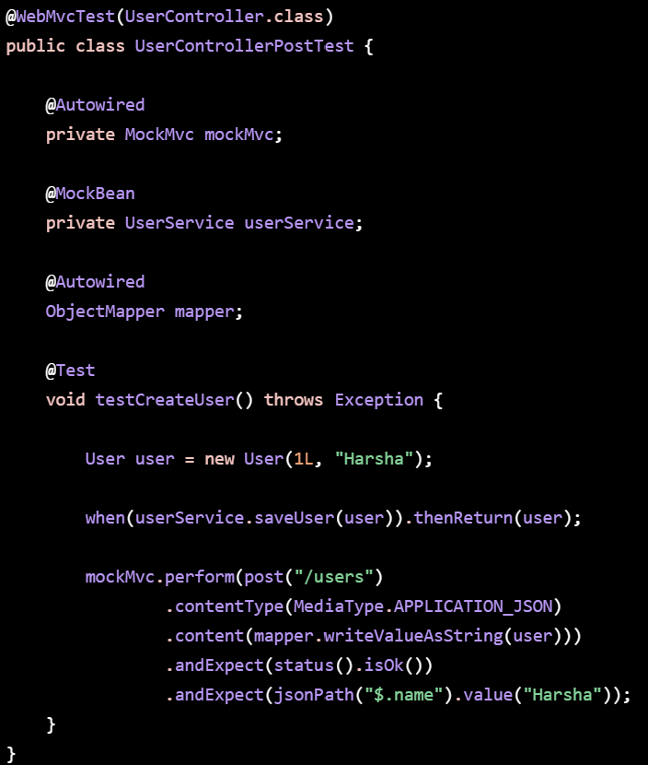

Exercise 6: Test Service Exception Handling
Task: Test how a service handles a missing user.

Test:

Write code for this.
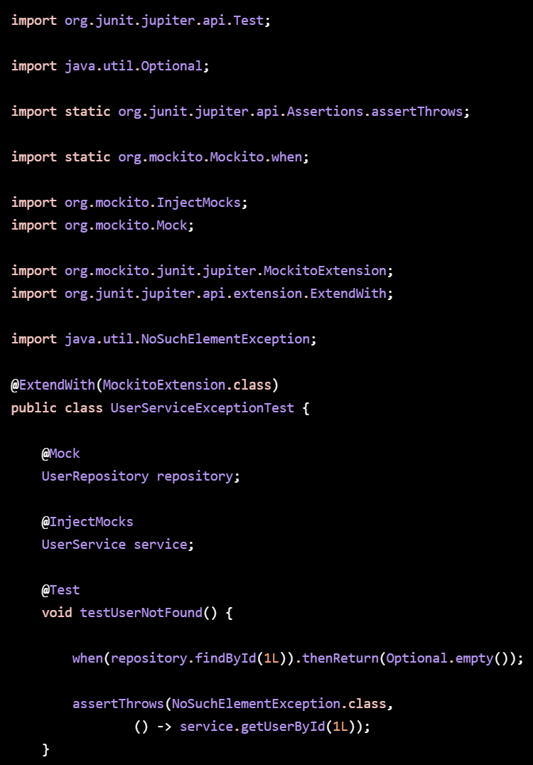

Exercise 7: Test Custom Repository Query
Task: Add and test a custom query method.

Repository:

public interface UserRepository extends JpaRepository<User, Long> { List<User> findByName(String name);
}

Test:

Write code for this.
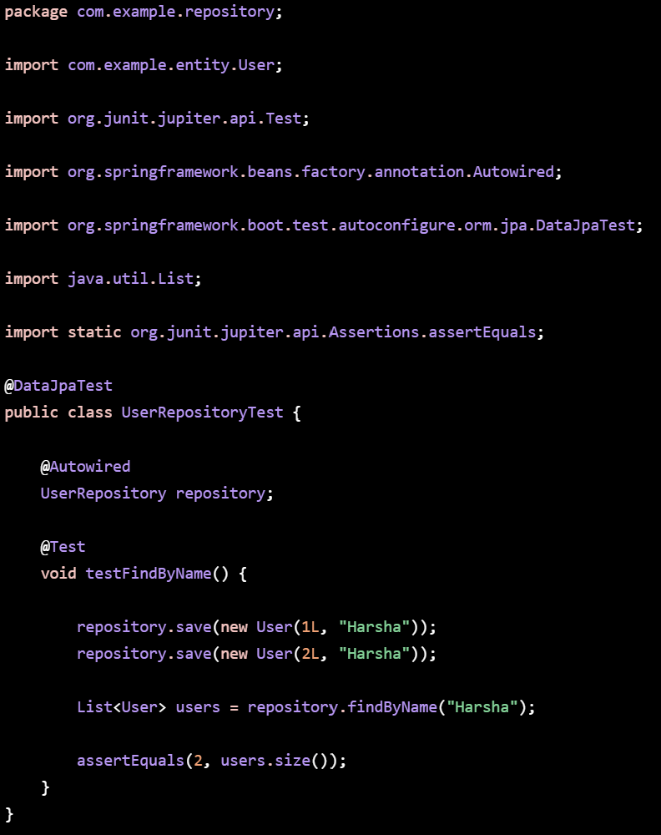

Exercise 8: Test Controller Exception Handling
Task: Add and test a @ControllerAdvice for handling exceptions.

Exception Handler:

@ControllerAdvice
public class GlobalExceptionHandler { @ExceptionHandler(NoSuchElementException.class)

public ResponseEntity<String> handleNotFound(NoSuchElementException ex) { return ResponseEntity.status(HttpStatus.NOT_FOUND).body("User not found");
}
}

Test:

Write code for this.
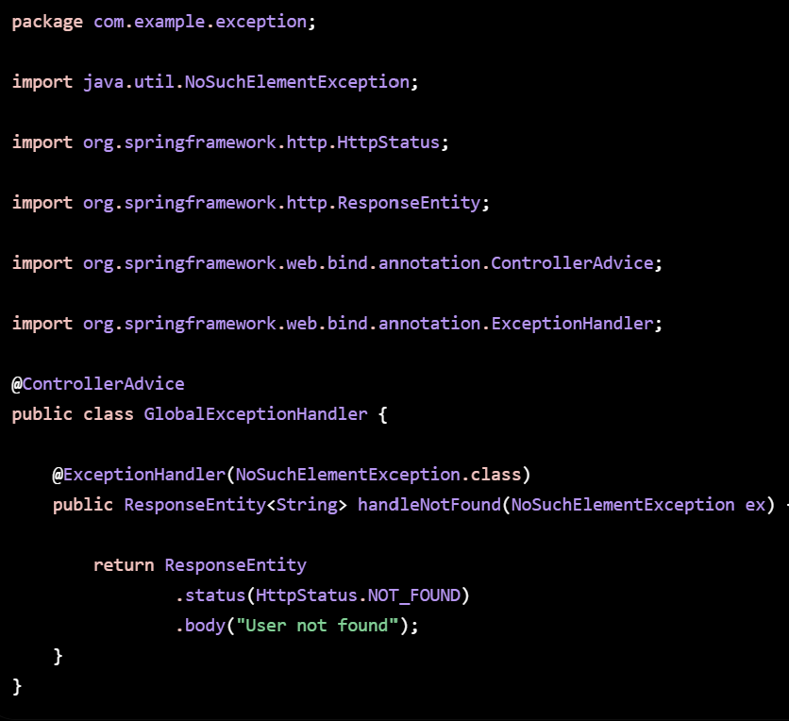

Exercise 9: Parameterized Test with JUnit
Task: Use @ParameterizedTest to test multiple inputs.

Test:

Write code for this.

